WD Purple Surveillance Hard Drive - 1TB WD11PURZ 64MB Cache SATA (CZONE)

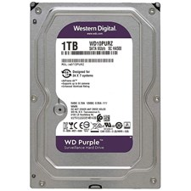

**Key Features**

* **Model**: WD11PURZ
* **Capacity**: 1TB
* **Cache Size**: 64MB
* **Form Factor**: 3.5-inch
* **Interface**: SATA III 6Gb/s
* **RPM**: 5400 RPM

**Compatibility**

* **Compatible with Major DVR/NVR Brands**: The WD Purple 1TB drive is compatible with a variety of security DVRs and NVRs (Network Video Recorders) from well-known brands, making it a versatile option for security systems.

**Reliability and Warranty**

* **MTBF (Mean Time Between Failures)**: WD Purple drives are engineered to have an MTBF of up to 1 million hours, making them highly reliable for continuous, 24/7 operation.
* **Warranty**: Comes with a **3-year limited warranty** offering peace of mind and protection against potential hardware failures within the specified period.